La design am folsoit https://stitch.withgoogle.com
folosind promutl:
Create a modern, clean, and highly responsive Single Page Application (SPA) web design for a university event management platform.

🎨 STYLE & BRANDING:
- Primary color: blue (use a modern palette: gradients, soft blues, accent highlights)
- Style: minimal, clean, glassmorphism or soft neumorphism elements
- Typography: modern sans-serif (e.g., Inter, Poppins)
- Feel: professional, academic, but engaging and dynamic
- UI should look premium and tech-focused

📱 RESPONSIVENESS:
- Fully responsive design (mobile-first)
- Optimized layouts for desktop, tablet, and mobile
- Smooth stacking of components on smaller screens

📌 MAIN FEATURES / SECTIONS:

1. 🔝 HEADER / NAVBAR
- Logo + University name
- Navigation tabs: Events, My Registrations, Materials, Feedback
- User profile dropdown (avatar + menu)
- Mobile hamburger menu

2. 📅 EVENTS LIST PAGE (MAIN VIEW)
- Card-based layout for events
- Each event card should display:
- Title
- Short description
- Date & time (start/end)
- Location
- Category (badge)
- Faculty (badge/tag)
- Participation mode (online/offline/hybrid)
- Status (upcoming, ongoing, finished)
- Include:
- "View Details" button
- "Register" button (if available)

- Add:
- 🔍 Search bar
- 🎛 Filters (dropdowns):
- Category
- Faculty
- Participation mode
- Status
- 📄 Pagination (modern style, rounded, smooth transitions)

3. 📄 EVENT DETAILS PAGE / MODAL
- Full event info:
- Title, full description
- Start & end datetime
- Location
- Registration deadline
- Max participants
- Organizer
- CTA buttons:
- Register
- Add to calendar

- Sections inside:
- 📎 Materials (files list with icons)
- 🏢 Sponsors (logos grid)
- ⭐ Feedback (ratings + comments)

4. 🧾 REGISTRATION SECTION
- Show:
- Registration status
- QR code (visual placeholder)
- Checked-in status

5. ⭐ FEEDBACK SECTION
- Star rating component
- Comment input
- List of feedback entries (clean cards)

6. 📂 MATERIALS SECTION
- File list with:
- File name
- Type
- Size
- Download button

7. 🎯 UI COMPONENTS:
- Modern dropdowns (rounded, smooth animations)
- Cards with subtle shadows and hover effects
- Buttons with gradients or soft glow
- Tags/badges for category, faculty, status
- Skeleton loaders for loading states

8. ✨ UX DETAILS:
- Smooth transitions and microinteractions
- Hover effects on cards and buttons
- Clean spacing and grid system
- Accessible contrast and readable text

9. 🎨 EXTRA:
- Use icons (Heroicons / Material style)
- Include empty states (no events, no materials, etc.)
- Include loading states
- Include success/error messages

📊 DATA MODEL:
Design should support displaying the following data structures:
- Events (title, description, datetime, location, category, faculty, status, registration info)
- Registrations (QR code, check-in status)
- Feedback (rating, comments)
- Materials (files)
- Sponsors (logos and links)

⚡ GOAL:
Create a visually appealing, modern university event dashboard that feels intuitive, scalable, and production-ready.

Insasi rezultatele sunt destul de bune:
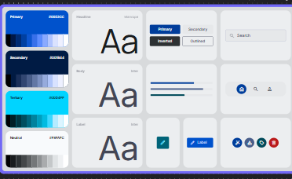 palitra de culori asa cum a fost specificat in prompt

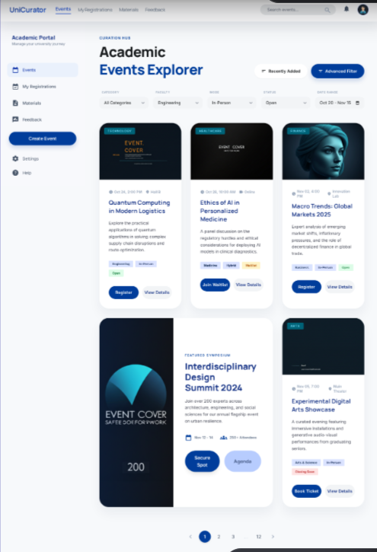

Designul cu toate evenimenetele:
si evenimentul principal:
